The pre-processing of EEG data was performed with EEGLAB software (https://sccn.ucsd.edu/wiki/EEGLAB_Extensions).

1. **Reading of .raw format**

EEGLAB → File Import data → using EEG functions and plugins → From Netstation binary simply file

The read-in file is shown in Figure 1.

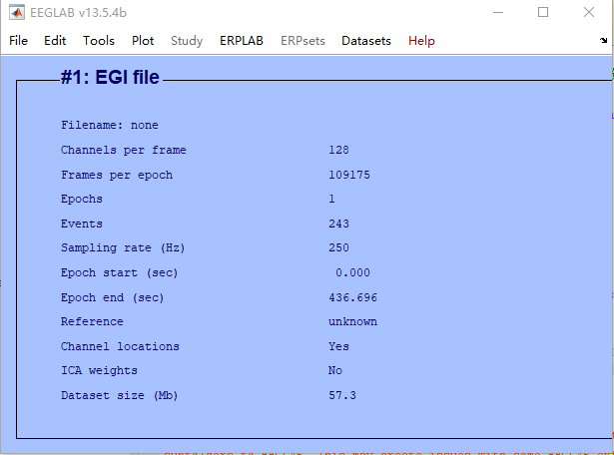

Figure 1 An example of data

1. **EEG preprocessing**

Since the default template electrodes in EEGLAB do not correspond to the electrodes of our electrode caps, you need to replace the electrode positions after loading the data using the following command:

load('H:\chan_info_egi_128.mat')

EEG.chanlocs=chanlocs

EEG.chaninfo=chaninfo

eeglab redraw

This electrode location file has been uploaded. The electrode positions before and after replacement are shown in Figure 2.

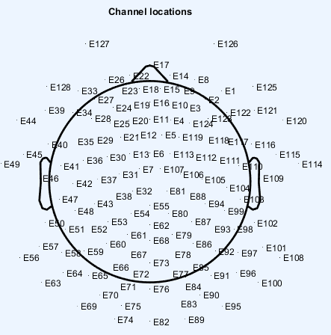 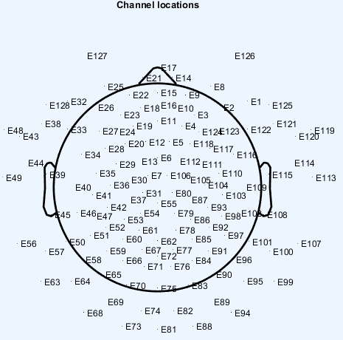

(b) After replacement

(a) Before replacement

Figure 2 Electrode location

Figure 3 shows that 128 electrodes correspond to some electrodes in 10-10 system. See literature for more details "P. Luu and T. Ferree, "Determination of the Geodesic Sensor Nets' Average Electrode Positions and Their 10 – 10 International Equivalents," Technical Note, 01/01 2000. " It is publicly available online at https://www.researchgate.net/publication/266609828_Determination_of_the_Geodesic_Sensor_Nets%27_Average_Electrode_Positions_and_Their_10_-_10_International_Equivalents.

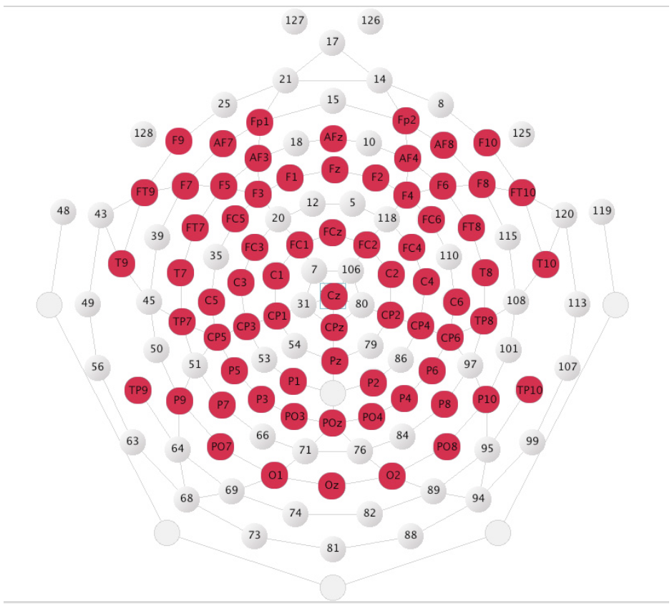

Figure 3 Layout illustrating the approximate 10 – 10 equivalent on the 128-channel HydroCel GSN.